

**Understanding your emotions and maintaining positive mental health.**

**Notes for teachers**

**(To be used in conjunction with Student Workbook)**

These notes and the accompanying student workbook have been produced by Surrey and Borders Partnership NHS Foundation Trust.

**For further information or guidance please contact nina.nwaosu@sabp.nhs.uk**

**How are you feeling? & Emotional Intensity (pg 2 & 3)**

**Objective:**

**•** To be able to accurately identify how they are feeling

• To understand that they may feel more than one emotion at the same time, and that sometimes these can be in conflict

* To understand that emotions can vary intensity, from mild, to medium to intense and be able to use emotions words appropriately to reflect the intensity level

**Task for students:**

* Use the feelings wheel to complete the intensity table with mild, medium and intense emotions.
* Discuss that where people place the words may vary and why this might be – for example, one person may feel that ‘fragile’ is an intense emotion and another person might use that same word to describe medium intensity

**Notes for teachers:**

Our emotions can be divided into primary and secondary emotions. Our ‘primary’ (or ‘primal’) emotions tend to be the most intense and are the ‘oldest’ from an evolutionary perspective. They four main ones are Anger, Fear, Sadness and Happiness. Most mammals have these emotions.

They are the drivers of automatic emotional responses, such as the fight or flight response to perceived danger. Because they are so important for keeping us safe, they tend to get priority in the brain – they shout loudest!

However, humans have evolved many many more complex emotions. We call these ‘secondary emotions’. Sometimes our secondary emotions can be drowned out by a primary emotion and this can cause us difficulties.

Remember that our emotions are trying to give us important messages about what is happening around us, motivate us to behave in a certain way, and help us communicate with those around us about what is important to us.

If we are not paying attention to the whole message, we may respond in an unhelpful way or mis-communicate with those around us. It’s like only having one or two words of a sentence – you need all the words in order to make sense of the message.

For example:

You have forgotten to do something because you are feeling very stressed and overwhelmed by how much work you have to do, and have been confronted about it. You may be feeling guilty for not doing the task. You may be feeling annoyed with yourself for forgetting and worried about the possible consequences. You may also be annoyed at the other person for confronting you about it because you are already feeling stressed and they are making you feel more stressed.

These are all secondary emotions, but some of them fall under the umbrella of stronger primary emotions such as fear or anger.

Because these are very strong, you may only respond to the anger – you start to shout and storm off, banging doors.

The other person cannot see inside you head. They can’t see all the emotions you are feeling. They can only SEE the anger.

No-one wants to help an angry person!

Being around an angry person may also trigger their own fear emotions in response, as they may see the angry person as a threat.

See how it escalates?

This is why its important to be able to identify accurately what you are feeling, and look past the initial strong primary emotion to understand what else is going on underneath.

We can use the feelings wheel to help with this.

When asked ‘how are you feeling’ most people will say one word, usually a primary emotion (shown in the centre of the wheel). But it can be helpful to look beyond that, move further out in the wheel to really pin down what the person is feeling.

Saying you feel ‘sad’ doesn’t really give you or anyone around you much information about what might be going on for you.

Saying you feel lonely, hurt, disappointed, frightened, and pressured give much more information. The more you know about how you are feeling the more helpful your and other people’s response is likely to be.

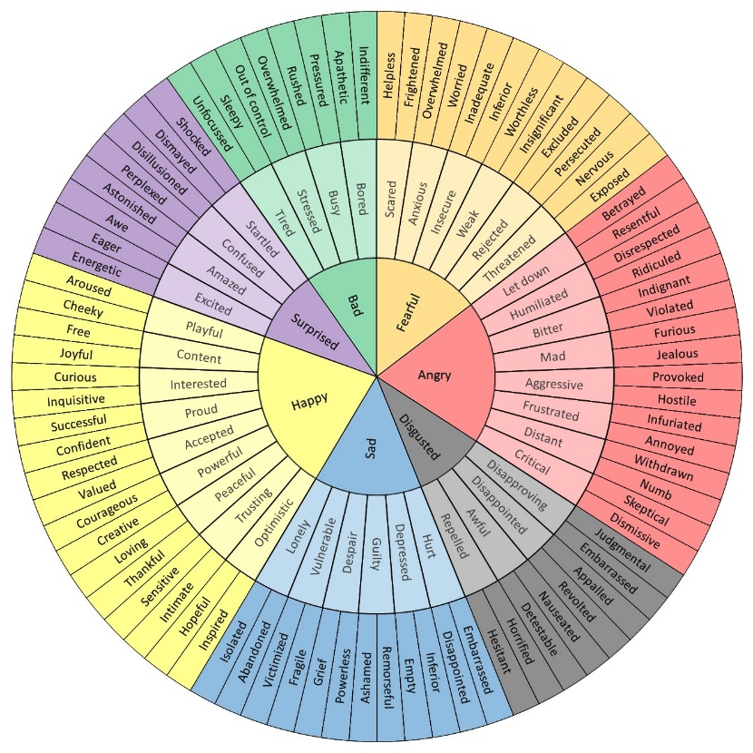

**Task:**

Use the feelings wheel (plus any other words they can think of) to complete the intensity table with mild, medium and intense emotions.

It may feel easier to start with the intense words as we feel these most strongly.

Below is an example of a completed table. There will be some variation in where people place some words, as different people will feel emotions differently but generally speaking this is what you would hope to see.

It may be interesting to note that when we are experiencing mild emotions, the people around us probably won’t have any idea what you are feeling. When they are medium intensity, other people may start to notice that something is happening. When it’s intense, the whole world knows!

But remember, other people cannot read our minds – they may know we are experiencing emotions of some kind, but unless we can communicate what those emotions are (perhaps using the feelings wheel to help) they may get the wrong message.

|  |  |  |  |  |
| --- | --- | --- | --- | --- |
|  | Fear | Anger | Sadness | Happiness |
| Mild | Worried, nervous, insecure | Annoyed, irritated, frustrated | Low, blue, glum, ‘meh’, flat, down | Content, upbeat, relaxed. optimistic |
| Medium | Scared, threatened, anxious | Angry, cross, agitated | Tearful, despondent, upset, miserable | Hopeful, motivated, excited, energised |
| Intense | Terrified, petrified | Rage, fury, irate | Devastated, despair, inconsolable, distraught | Euphoric, ‘Cloud 9’, joyful, ecstatic |

**What’s the message? (pg 4)**

**Objective:**

* To be identify the function of some basic emotions and their possible causes
* To identify the advantages and disadvantages for each emotion

**Task for students:**

* In the table, identify what message each emotion is trying to convey
* Identify possible causes for that emotion being triggered
* Identify the advantages and disadvantages of each emotion

**Notes for teachers:**

Our emotions act like a messenger – telling us that something important is happening around us or to us that we need to pay attention to.

Each emotion has its own message and can be triggered by many different scenarios.

**Discussion points:**

* Fear can be triggered by something tangible and direct (like a speeding car) and also by intangible events, for example fearing for your future due to the pandemic
* Guilt can also be experienced even when we have NOT done anything wrong. Other people can seek to place blame upon us unfairly, but we have a choice whether to accept it or push it back if it doesn’t belong with us.

|  |  |  |  |  |
| --- | --- | --- | --- | --- |
| **Emotion** | **Message** | **Possible Cause** | **Advantage** | **Disadvantage** |
| **Fear** | I or someone/something I care about is in danger or under threat | Speeding car, someone acting aggressively, pandemic | Keeps me safe | Can be very strong and overwhelming. Can hold me back too much and be too strong for the actual situation |
| **Anger** | I have been wronged, treated unfairly, denied justice | Being pushed in front of, being cheated, being treated unfairly | Prompts me to defend or protect myself | Can be very strong and overwhelming. Can be triggered too easily and I may react too strongly for the situation (over-react) |
| **Sadness** | This situation/environment does not feel good or comforting to me, I want it to stop | Grief, loss of friendships or relationships, loss of opportunities | Alerts me to things in my life I might need to change. Prompts me to seek help or care, or self-care | Can linger for a long time. I can lose sight of the good things in my life if I am only paying attention to the unpleasant things |
| **Guilt** | I have done something wrong | Making a mistake, behaving poorly towards others | Gives me the chance to fix the mistake, apologise, make things right, learn from my mistake | Sometimes things can’t be fixed or undone. Sometimes it’s not my fault but other people are trying to make me feel guilty. Can linger for a long time. |
| **Happiness** | This situation/environment feels good and I want it to continue | Stability in relationships, stability in school and home life | Encourages me to keep doing these things, being with these people | Doesn’t last forever |

**Healthy coping skills – TIPP (pg 5-7)**

**Objective:**

* Learn how to reduce emotional intensity safely in a crisis

**Task for students:**

* Try out the TIPP skills, especially paced breathing and progressive muscle relaxation

**Notes for teachers:**

The TIPP technique can be used in times of intense emotions when things feel overwhelming.

Usually, when people find themselves in situations like this, their ability to think clearly is reduced and you are more likely to make poor or dangerous choices when you are in this ‘survival’ state. The TIPP technique can help you reduce the intensity of your emotions quickly and safely.

TIPP skills are short term – you will most likely need to use more skills afterwards as well depending on how you are feeling.

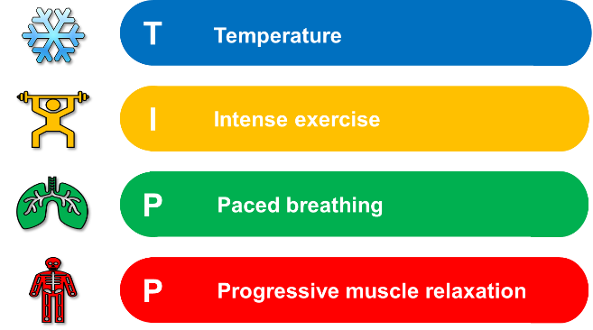

### T - Temperature

All mammals possess something called a ‘*dive reflex’,* which is activated when we put cold water on our faces or submerge ourselves in cold water.

The reflex tells our body to slow our heart to below its resting heart rate.

It does so by activating our parasympathetic nervous system, which is responsible for our *‘rest and digest’* functions.

This can be done in a variety of ways.

* You could dip your face in a bowl of cold water for 5 seconds
* Splash cold water on your face
* Sit in a comfortable spot and place cold ice or gel packs on your face
* Cover your face with a cold washcloth.

However, the effects of this skill are short-lived. Be sure to use another skill to help calm yourself down further - once you are able to.

### I – Intense Exercise

Often when we feel intense emotions, we also feel an intense urge to act. This is often because our fight/flight response has been triggered and our body has responded by getting us ‘ready for action’. Sometimes our urges tell us to *‘do’* something negative.

Intense exercise helps soothe the body’s urge to *‘do something now!’*. It is especially useful when you are feeling very angry or very fearful/anxious

It also has mood-boosting benefits, both during and after the physical activity.

After exercise, our parasympathetic nervous system is activated again, naturally bringing our heart rate and respirations to a more manageable level.

Even if it’s just jumping up and down for 30 seconds, it can be very effective at taking some intensity out of emotions and also release some nervous energy.

You could try:

* Running up and down stairs
* Running on the spot
* Star jumps
* Using a punchbag (or pillow!)

***P – Paced Breathing***

Slowing your breathing down, and just the act of concentrating on your breathing for a few minutes, can help reduce the intensity of your emotions. This skill can be done anywhere and no one else will know you are doing it either!

Try the following technique:

1. **Breathe** in deeply through your nose (*abdominal breathing*) for **5 seconds**
2. **Hold** for **5 seconds**
3. **Breathe out** through your mouth for**7 seconds**.
4. **Repeat** - Do this for several minutes.
5. **Stop** when your breathing is calmer

The aim is to **slow** your breaths, making your out-breath longer than the in-breath.

Practice by placing a hand on your stomach or chest to make sure that you are breathing in as fully and as deeply as you possibly can. This skill needs to be done for several minutes to be most effective.

**P – Progressive Muscle Relaxation**

Refocusing your mind onto various muscle groups throughout the body provides an excellent distraction from racing thoughts.

The goal here is awareness of body tension. Allow yourself fifteen minutes for this exercise.

Begin with your toes:

* Scrunch up your toes as hard as you can
* Hold the tension for 5 seconds
* Quickly relax the muscles completely – you can exhale and shake out that area of the body if that helps
* Wait 10 seconds before moving on to the next muscle group.

Continue by working your way slowly up your body, so after the toes, switch to the muscles around your ankles and lower leg, then your knees, then thighs etc, all the way up to your face and head. Don’t forget your hands!

**Healthy coping skills – Mindfulness (pg 8-15)**

**Objective:**

* Understand what is meant by the term ‘mindfulness’
* Learn how to practice mindfulness effectively

**Task for students:**

* Try out some mindful activities
* Try keeping a mindful journal for a week

**Notes for teachers:**

Mindfulness is being **aware** of your thoughts, emotions, physical sensations and actions - in the present moment - without judgement.

We spend a huge amount of time and mental energy either dwelling on the past or worrying about the future. When we practice mindfulness, our thoughts tune into what we’re experiencing **right now**.

Often, we may feel like our thoughts are racing and we struggle to concentrate, we get easily distracted by thinking or worrying about other things. Learning to be in control of where you place your attention - being in the *“here and now” –* can help you feel more in control and has been shown to reduced symptoms of anxiety, depression, chronic pain and binge eating. It also increases your tolerance and ability to cope with distressing situations. This is called ‘emotional resilience’.

* **Mindfulness** helps you focus on one thing at a time in the present moment, and by doing this you can better control and soothe your overwhelming emotions.
* **Mindfulness** can help to relax our body by activating our parasympathetic nervous system, encouraging our bodies to transition into a state of relaxed awareness.
* **Mindfulness** can help you to learn to identify judgemental thoughts.

(Challenging negative thinking is a separate skill explained elsewhere in this school pack).

**How to practice mindfulness effectively:**

**Observe**

* Notice what thoughts and emotions you may have – but don’t judge them! They are simply ‘there’. Try not to react to emotions.
* Notice how your body is feeling – tense, relaxed, too warm, too cold, any pain or aches, tight or comfortable clothing
* Notice your environment – temperature, smells, sounds, textures, is the seat comfortable, how does the table feel to touch, colours
* Use all your 5 senses

**Describe**

* Use descriptive language ‘the table is cool and smooth’
* Acknowledge emotions and thoughts without examining them more deeply ‘I am having the thought that…’

**One Mind Fully**

* Focussing on one thing at a time with full awareness – the opposite of multitasking.
* Example – eating a meal while scrolling through your phone and listening to music OR eating the meal with no distractions and focussing your mind fully on the meal, the smells, flavours, textures, physical process of eating and swallowing etc.
* Distractions will happen – that’s normal. When we notice our mind starting to move away from the task in hand, we need to re-focus and begin again – without judgement!

Effective mindfulness take practice!

**Examples of things that can be done mind-fully**

|  |  |
| --- | --- |
| Colouring | Gardening |
| Exercise – no music! | Taking a bath or shower |
| Eating and drinking | Brushing teeth (try with your ‘other’ hand!) |
| Cooking | Holding/interacting with a pet |
| Drawing/art/sculpting | Observing an everyday object |
| Walking – no phone or music! | Breathing |
| Being in nature | Exploring sensory/fidget toys |

Students can have a go at building some time for mindfulness into every day – they have a 7 day mindfulness journal in their workbooks they might find helpful or they can try some of the activities listed.

Schools might consider trying to set aside a few minutes for mindfulness into every morning, as a way to start the school day.

**Mindful Activity to try: Mindful Malteasers**

Each student is given a Malteaser (you can also use things like ‘Heros’, ‘Roses’, Lindt balls etc – something with differences in texture and taste work best).

The teacher will prompt students as the do the activity. Students are not required to answer during the activity, but to just notice their responses, which can be discussed as a group at the end of the activity. They should also pay attention to their thoughts wandering off the activity, and judgemental thoughts. They can close their eyes if that feels comfortable.

Start by observing the malteaser:

* What colour is it? Is it the same colour all over?
* What is it’s texture and shape? Smooth, bumpy? Is it a perfect sphere or is it more oval?
* Is it light or heavy? If they place it on the desk does it roll away or stay still?
* Does it smell?
* Does it have any flaws or marks on it?

When ready, the students can put the malteaser in their mouth – DON’T BITE OR CHEW!!

Holding the malteaser in their mouths they can now notice:

* The taste – is it strong or not so strong?
* How does it feel on their tongue? What is the texture of the chocolate as it begins to melt and how does it spread around their mouth?
* It their mouth watering in response to the malteaser?
* Is it easy to keep the malteaser in one place in their mouth or do they move it around? If they are holding it still, can they move it and how does it feel to do that? If they are moving it around, how does it feel to try and hold it still?
* As the chocolate starts to melt, they will start to notice the biscuit centre. How is the texture different? How does it feel as the biscuit begins to dissolve.
* Eventually there will be nothing left

As a group, discuss how it felt to be totally focussed on the Malteaser only for that amount of time. Did students find their mind wandering? Any thoughts?

It’s very common for people trying mindfulness for the first time to experience critical or judgemental thoughts such as ‘this is stupid’, ‘why are we doing this’, ‘this is boring’ etc. The important thing is to notice that those thoughts are present, not to judge ourselves harshly for having them, but to then try and re-focus onto the activity.

**Healthy coping skills – Challenging Negative Thoughts (pg 16 – 19)**

**Objective:**

* Understand that everyone can experience ‘thinking errors’ when under pressure or emotionally stressed
* Understand how thoughts are not the same as facts, and they can be challenged

**Task for students:**

* Identify some of the common thinking errors they may have experienced
* Use the worksheet to challenge negative thoughts

**Notes for teachers:**

When we are faced with a challenging situation, we have an emotional reaction to it.

This reaction is often accompanied by certain thought processes which are often unhelpful, and distressing and they increase our emotional suffering *(a vicious cycle).*

So an event occurs, which triggers an emotional reaction, which triggers thoughts, which triggger more emotions, which trigger more thoughts…and this is how intensity levels can quickly escalate.

**Event** leads to **thinking error** which affects your **emotions**

**OR**

**Event**



**Thoughts**

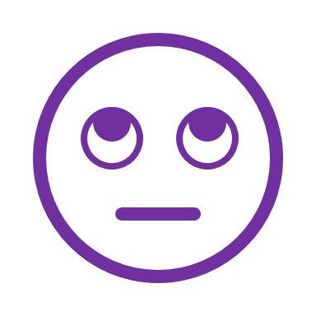

**Emotions**

**Event**



**Emotions**



**Thoughts**

When we are under stress we tend to think illogically, and we can make thinking errors under pressure which are quite common, and we may to mis-interpret situations in problematic ways.

Those errors in thinking are called **cognitive distortions**.

The main types of cognitive distortions are described in the student workbook with some examples.

Discuss the common thinking errors as a group, do students recognise having experienced any of these thinking errors at times? Students can place a tick next to any they frequently recognise in themselves.

**Common Thinking Errors**

|  |  |  |
| --- | --- | --- |
|  | **Tunnel Vision** | You pick out the negative details in any situation and dwell on them exclusively, filtering out any positive or neutral details. You conclude that the whole situation is negative. **Example:** You get a test back from school, with 5 out of 100 questions marked wrong, and you focus only on the 5 wrong, ignoring the 95 questions you answered correctly. |
|  | **Reject the positive** | You ignore evidence that challenges your negative attitude, often finding quick and clever ways to discount any positive information. You reject positive experiences by insisting they *“don’t count”* for some reason or other. **Example:** Someone compliments you on your appearance. You immediately reject the statement by saying the person has poor taste. |
|  | **Over generalisation** | You come to a general conclusion based on a single incident or piece of evidence. You believe that if a negative event happens once, it will always happen, again and again. Frequently involves use of the words “always” or “never.” **Example:** You ask someone out for a date and the person turns you down. You conclude that no one will ever want to go out with you. |
|  | **Jumping to conclusions** | You jump to a negative conclusion that is not supported by the facts or situation. **Example ‘Mind Reading’:** You believe you know what someone else is thinking about you and you react accordingly, without checking what they are ACTUALLY thinking. |
|  | **Catastrophising** | Believing there will always be a negative outcome of any situation, and deciding that if this outcome happens, it will be a disaster. This often involves exaggerating the effect of something negative. **Example:** ‘I’m going to fail my exams and then I won’t get into University and then I won’t be able to pursue the career I want. And even if I pass the exam, I won’t get the grade I need to get into my first choice of Uni. And even if I get into Uni, I will fail my degree. And even if I get my degree, no one will offer me a job. But I’d be rubbish at it anyway!’ |
|  | **Fortune telling/self-fulfilling prophecy** | Believing something awful will happen and then acting or reacting as if it already has, therefore causing the situation to come about. **Example:** ‘I’m not going to get the part in the play so there’s no point in auditioning.’ So you don’t audition and don’t get the part in the play. |
|  | **Labelling** | Attaching a negative label to yourself or others and then viewing yourself/them in a negative light from then on **Example:** ‘I’m a loser’, ‘he’s a liar’ |
|  | **Should/must statements** | You have an ironclad list of rules about how things should be, especially how you and others should act. When you or others don’t meet these high expectations, you feel guilty and critical towards yourself or pass judgement and become resentful towards others. Look out for thoughts that include ‘should’ and ‘must’. **Example:** You believe that people should always be on time no matter what. A friend is a few minutes late to meet you. You judge her harshly and act ‘off’ with her. You are not interested in reasons beyond her control for why she is late and you don’t forgive her. |
|  | **Personalisation/Bias** | You think that if something has gone wrong it’s your fault, or it’s always about you. **Example:** Your friend is unusually quiet and you assume they are upset with you for something, or a teacher calls you over to speak to you and you assume you are in trouble. |
|  | **Fallacy of fairness** | You believe life should always be completely fair and get very angry and upset when it is not. **Example:** You submit a picture for an art contest. You don’t win and feel upset and angry and think that you should have been equally rewarded because you put in a lot of effort. |
|  | **Bias** | You come up with a negative explanation for the actions of others. **Example:** Someone bumps into you are lunchtime causing you to drop your drink. You conclude they did it on purpose to humiliate you. |
|  | **Minimising/Selectiveness** | You minimise or ignore information that does not fit with how you view yourself or your situation. You focus only on one piece of information (usually negative) and ignore the rest. Example: You play a musical instrument and play six pieces of music. You make a small mistake in one piece. Afterwards, your music teachers complements your playing in all the pieces, and notes the small error as something to work on for next time. You respond with ‘why do you only point out my faults?’ |
|  | **Fallacy of control** | You believe that you should be able to always control your environment and situations and when that doesn’t happen you get very distressed. Example: You burn a meal you are cooking because you are also busy trying to clean your room and finish your homework. You believe you should be able to multitask in this way and that you are a failure for not being able to do so on this occasion. |
|  | **Black and White thinking** | Things are all or nothing. Everything is all good or all bad, right or wrong, perfect of totally failure. In reality, there is always a middle ground. Look out for words like ‘always, never, everything, everyone’. Example: You make a spelling mistake in your work ‘I wanted it to be perfect, now it’s totally ruined, I always fail at everything. I never get anything right.’ |
|  | **Blaming** | You blame yourself for things that are not your responsibility, or you blame others for everything and never accept responsibility yourself. **Example blaming others:** You forget to complete your homework and blame your mum for not reminding you. **Example blaming yourself:** Your wallet is stolen from your bag and you blame yourself for it’s loss. |
|  | **Superstitious thinking** | Illogical cause and effect **Example:** if something good happens then that means something bad is going to happen next. |

You can dwell on unhelpful thoughts and not challenge them, or you can be choose to notice and challenge thinking errors. Thoughts are not facts. They can and should be tested and challenged if they are causing us distress, or to view ourselves or others in a negative way.

We can challenge negative thinking patterns and thinking errors to change how we are feeling about a situation or event.

**Task:** Have students choose one thought about themselves and have a go at challenging it using the prompts in their workbook.

**Examine the** **EVIDENCE**



* Am I confusing a fact with an opinion?
* What is the evidence for the negative thought?
* What is the evidence against the negative thought?
* Are there any small things that contradict the thought? Perhaps things I am discounting as unimportant?

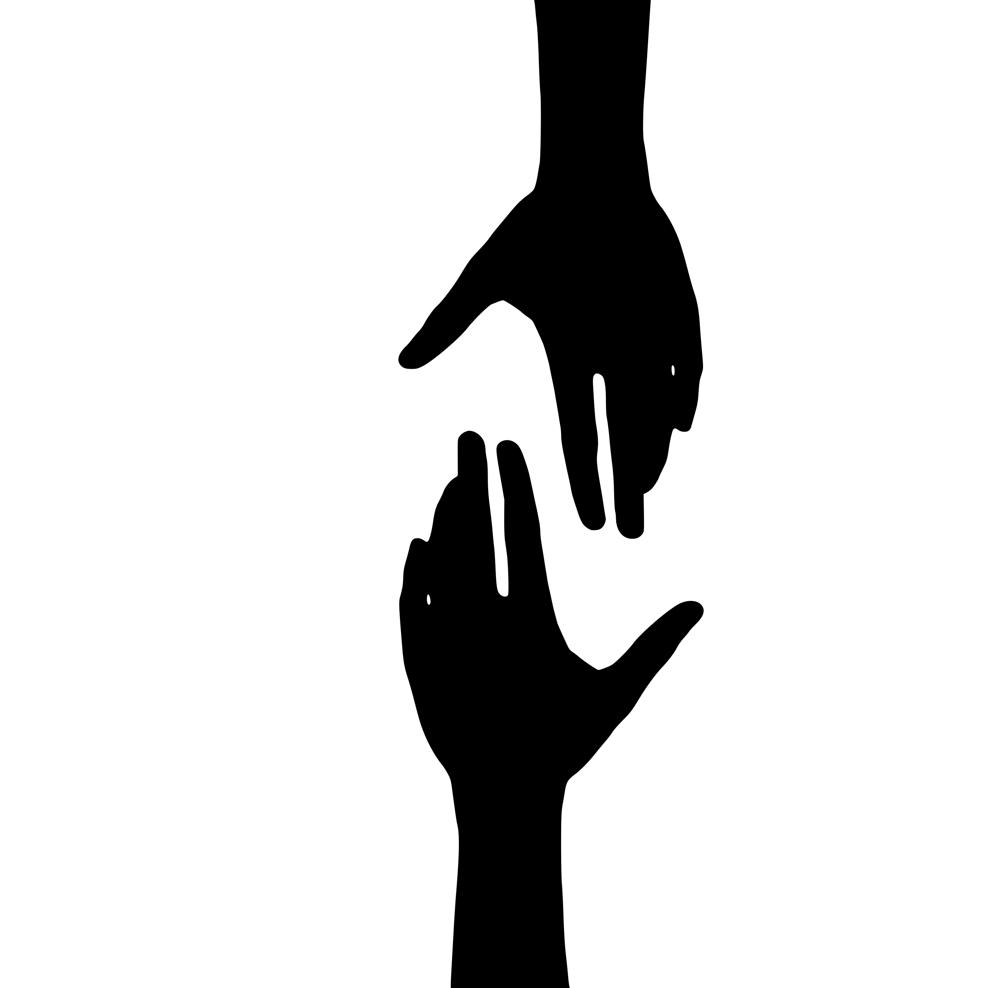

**Question the** **HELPFULNESS**

* Are these thoughts helpful to me?
* Will thoughts like this help me to achieve my goals?
* Do thoughts like this truly have my best interest at heart?

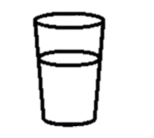

Empty



Full

**Explore** **ALTERNATIVE PERSPECTIVES**

* If my friend knew I was having this thought, what would they say to me? (Try asking!)
* If someone I loved had this thought, what would I tell them?
* What would batman say to me about this thought?
* Am I making the mistake of assuming my perspective on this issue is the only one?
* Ten years from now, if I look back on this situation, will I look at it any differently?
* If this was happening to someone else how would I view the situation?



**Uncover BIAS**

* Am I thinking in all-or-nothing terms? (Am I using words like ‘always’ or ‘never’?)
* Am I catastrophizing?
* Am I jumping to conclusions or making assumptions that are not justified by the evidence?
* Am I holding myself to a higher standard than I would hold other people?
* Am I labelling myself?
* Am I focussing on my weaknesses and minimising my strengths?
* Am I making unreasonable demands? (Am I using words like ‘should’ or ‘must’?)
* Am I blaming myself for something over which I have no control?

**Healthy coping skills – Grounding (pg 20-21)**

**Objective:**

* Learn about and explore the grounding skill

**Task for students:**

* Identify grounding activities to try themselves
* Think about what might go into a soothing box

**Notes for teachers:**

Grounding acts a bit like pressing a ‘reset’ button for your brain. Grounding techniques distract you from the situation you are in, or the emotions that are causing you distress, and refocus your attention on what’s happening in the present moment.

Grounding techniques often use the five senses — *sound, touch, smell, taste, and sight* — to immediately connect you with the here and now.

How you ground yourself is highly personal. What works for one person may not work for another, and what works in one situation may not work in a different situation. You may need to do some trial and error to figure out what grounding techniques work best for you.

**Task:** Discuss activities based around the 5 sense that could be used for grounding. Students can write their ideas in their workbook. Grounding does not necessarily have to be something pleasant – just something that grabs the attention. But be sure it’s not a harmful action. For example, spoon of mustard is not pleasant but is a safe grounding strategy. Self-harm, such as cutting, is grounding, but is harmful.

Sight:

* Listing all the things you can see starting with a certain letter or colour or shape
* Focussing on an object such as a lava lamp or sensory object

Sound:

* Naming 5 things you can hear
* Listening to a comforting sound such as birdsong or the ocean
* Listening to a favourite song or audiobook.

Touch:

* A soft blanket or rough material
* Tapping your hands, arms, collar bone or face
* Use temperature – such as cold water or a warm bath
* Fidget/sensory toys

Smell:

* A favourite food or drink
* Strong smelling flowers or perfume
* A comfort object that has a smell that prompts positive memories or associations
* Diffuser sticks, essential oils, scented candles

Taste:

* A favourite food
* Strong tasting food like marmite, mustard, pepper or lemon

Things can also be combined – for example eating cold ice cream – taking a warm bath with essential oils and scented candles.

**Create a soothing box**

It’s unlikely you’ll have many of these things to hand when you need them, so it can be helpful to plan ahead and create a ‘soothing box’ full of the things you find helpful for grounding and calming. You can also create a smaller ‘portable’ soothing box to carry around in your bag - like a mental health first aid kit.

Students can use their workbook to list the things they might put in their soothing box. Any box or even a bag can be used – a shoebox is a good size – decorating the box can be a mindful and calming activity in itself.

Things to put inside could include:

* Sensory items – Something to smell, touch, look at and/or taste
* Something to trigger positive memories, like photos
* Little notes or cards from friends and family that make you feel good
* A favourite food or drink item (non-perishable!)

**Healthy coping skills – Prompt Card (pg 22)**

**Objective:**

* Think about how a prompt card might be helpful and who they might share it with

**Task for students:**

* Complete their own personal prompt card

**Notes for teachers:**

A prompt card is aimed at supporting you during vulnerable times and gives suggestions of what you can do to manage. It will be unique to each individual

It is helpful for this prompt card to be easily accessible, so it is quick to use in the moment, and for it to be small and discrete so you can carry it around with you, say in your purse or wallet.

You can also share the prompt card with other people, such as family members, teachers, so they know how to help you if you are distressed.

Here are some suggestions of what to include that others have found helpful:

* Prompts to reach out for help; *phone or speak to a certain person*
* Positive affirmations/ quotes *e.g. ‘This too shall pass’ ‘I got through this before I can do it again’ ‘I can cope’ ‘I am worthy of love and respect’.*
* Reminder of the TIPP skills
* Prompt to use distraction and grounding skills; *do my colouring, use my fidget toy, go for a walk*
* Prompt to use your soothing box
* Statements to challenge your common negative thoughts.

**Task:**

Students can create their own prompt card in the workbook

**Healthy coping skills – PLEASE Skills (pg 23)**

**Objective:**

* To understand how taking care of our physical needs can have a positive impact on our mental wellbeing

**Task for students:**

* Think about what they can do/are already doing to meet their physical needs in the PLEASE skill areas

**Notes for teachers:**

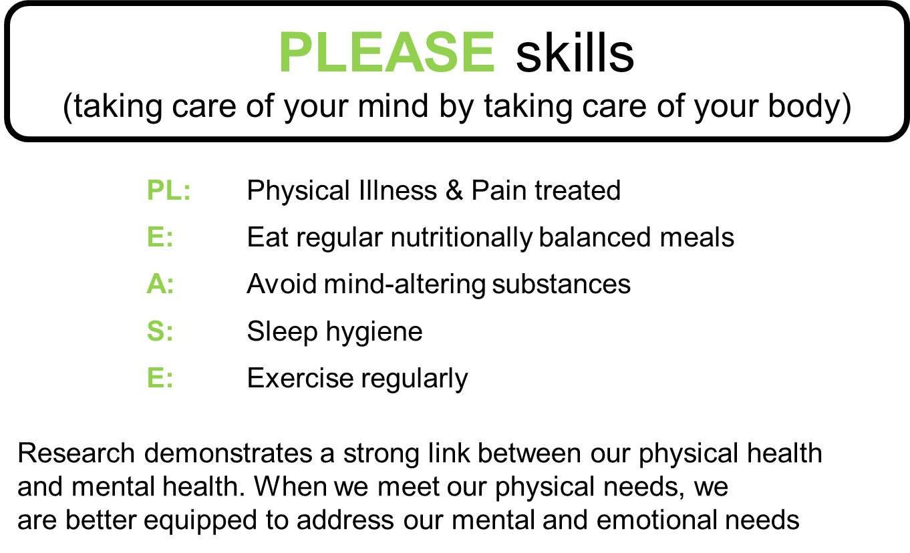

When we meet our physical needs, we are better equipped to address our mental and emotional needs.

It’s like when you build a house. You need to have a strong foundation to start from. If you don’t, the house will crumble at the first sign of trouble. It’s the same for us. By establishing a strong foundation to start from, we are better able to cope with the stresses and trials that everyday life can bring.

## **Physical Illness & pain treated**

Research demonstrates a strong link between physical and mental health. If you are physically ill in any way, it can make coping with difficult emotions and decision making much more difficult.

By taking care of your body, you are also taking care of your mind. Taking care of your physical health can be as simple as brushing our teeth, washing our face and hair, shaving. Getting regular haircuts, and having a skin care routine not only addresses our physical needs, but can also be acts of self-care and help us feel better about ourselves.

It can also mean ensuring you book and attend GP appointments for routine check-ups, to discuss any medications you take regularly, or when we’re experiencing ill health or injury.

Sometimes, when we are experiencing periods of low mood we can neglect our most basic physical needs.

## **Balanced Eating**

Sometimes the everyday stresses in life can make it difficult for people to eat healthy meals on a regular basis. They may feel like they don’t have sufficient time to eat well, or they may be experiencing physical symptoms related to their emotional state that mean they don’t feel like eating (eg. feeling nauseous due to feeling nervous or worried). Sometimes we may eat more than our body needs when we feel emotionally distressed.

As difficult as it can feel, eating a balanced diet is an important aspect of the **PLEASE** skill. When you give your body and brain the nourishment it needs, you’re better able to cope and regulate.

Focus on eating balanced meals that make you feel good.

Eating a balanced diet does not mean going on a stringent diet plan. It means eating a variety of foods that will adequately fuel your body and brain, so it is equipped to meet the demands of daily life.

This ideally means eating 3 meals a day, with a variety of carbohydrates, protein, and healthy fats.

Try to limit (*but not cut out!*) processed foods and sugars, as these can lead to dips in our energy levels, mood and often leave us hungry and craving more sugar.

If this concept seems daunting, you can start with small steps.

You could consider adding in supplements to compliment your diet, such as multivitamins, adding in one extra serving of fruit to your day or make one healthy swap to your routine. You can continue making small changes until you have a well-balanced diet.

The NHS Change4Life website can be a great place to start with making small changes.

[Sugar Swaps for Kids | Make a Swap | Change4Life (www.nhs.uk)](https://www.nhs.uk/change4life/food-facts/sugar/sugar-swaps-for-kids#all-swaps)

## **Avoid Mood Altering Drugs**

Mind-altering substances can keep you from being able to use healthy coping mechanisms effectively. This is because you brain responds chemically to the emotions you are experiencing. And if you then also use mind altering substances, that introduces MORE chemicals into your brain which can interfere with the brains natural ability to process emotions and other functions. Sometimes the interference can be long lasting or even permanent.

These substances include:

* Alcohol
* Caffeine
* Nicotine
* Medications prescribed to other people
* Illegal recreational drugs

If you are coping pretty well with your emotions, don’t take the risk of interfering with what your brain is currently doing really well. If you are already finding it difficult to cope with your emotions, adding more chemicals into the mix is only going to make things more complicated.

## **Sleep Hygiene**

Sleep hygiene is having good sleep habits.

We need sleep to prevent exhaustion, allow our body to heal itself, boost our immunity and improve our mood, memory, and concentration. An unhealthy sleep cycle can throw your physical health off-balance.

A good night’s sleep will help you to feel better equipped to cope with whatever comes your way the next day.

People’s needs vary and how much sleep you need will change throughout your life; babies need around 16 hours of sleep, primary age children need around 9-12 hours, and teenagers need between 8-10 hours of sleep. This is because your brain is still developing, up until you are about 25. And so your brain needs enough rest to be able to grow and develop and process new information.

Once your brain is no longer growing, your sleep requirements go down, but it still varies person to person. Most adults feel 6-8 hours is sufficient to function at their best, whilst others feel they need 9+ hours.

Sometimes we might experience difficulty getting to sleep, waking frequently in the night, or waking early in the morning and not being able to get back to sleep. This can result in us feeling tired, tense and more likely to worry about sleeping. This worry can then also make it harder for us to sleep!

While many people get too little sleep, some people with disorders like depression can get too much sleep. It’s important to find a healthy balance to give your mind the best chance at emotional regulation.

If you are struggling with your sleep, it can help to consider things like:

Your sleeping environment

* Is it too dark or light
* Are there any distractions like a blinking light on a TV
* Too hot or cold,
* Airflow
* Noise

Your thinking

* Make time for mindfulness before bed to help clear your mind ready for sleep
* Make a list of things you need to do the next day so you don’t lie there worry about forgetting
* Keep a journal or write out all your thoughts and physically put them to one side

Your behaviour

* No screens for an hour before you try and sleep. When you lie down to sleep turn off your phone, put it on ‘flight’ mode, or ‘night mode’ or leave it outside your bedroom.
* Don’t eat too late
* Try and get fresh air everyday (because exposure to sunlight generates the ‘sleep hormone’ we need to help us sleep later)
* Only use your bed for sleeping (if possible)
* Don’t stay in bed if you can’t sleep. Get up and do a low stimulation activity like reading or colouring, for 30mins (or less if you start to feel tired) and then try again.
* Try and be physically active during the day so your body is ready for rest at night time

**Exercise**

The mental and physical health benefits of regular exercise have been researched extensively.

Exercise can help to treat underlying physical illnesses, regulate sleep patterns and improve mental wellbeing.

Getting enough exercise looks different for everyone.

Some people enjoy running or lifting heavy weights, others would prefer to get on a tennis court, go swimming or enjoy a long walk with a friend.

Try to make time for at least 20 minutes of exercise every day.

If this sounds daunting or unrealistic, don’t worry.

The idea of moving your body should be a celebration of what it can do, not a punishment, so make sure you choose activities that spark joy, rather than dread.

**Stress Bucket (pg 24)**

**Objective:**

**•** To understand how external and internal stressors can build up and affect our capacity to manage new stressors on a day to day basis

• To understand how healthy coping strategies can reduce the stress level and increase capacity to cope, but that unhelpful coping strategies just recycle the stress for later

**Task for students:**

* To identify their own stressors and explore other potential stressors they can think of
* To discuss/share helpful and unhelpful coping strategies they may have tried or heard of

**Notes for teachers:**

The water in the bucket represents how stressed we may be feeling.

The more stressed we feel the higher the level of water in the bucket.

The taps represent ways to reduce stress and lower the water in the bucket.

We need to identify coping strategies to allow us to reduce our stress levels.

If we do not do this the water fills up to the top and overflows.

This is usually when we feel completely overwhelmed and very stressed and feel unable to cope.

External and internal stressors each impact the levels in our stress bucket and our ability to manage emotionally. External stressors can also generate internal stress. For example, a traumatic event generating painful memories.

**Examples of external stressors:**

* Physical injury
* Sickness
* Relationship struggles
* Family struggles
* Financial strain
* School pressures

**Examples of internal stressors:**

* Low self-esteem
* Negative self-image
* Perceived lack of control
* Painful memories

**Examples of physical coping strategies:**

* TIPP Skills
* Self-care activities
* Talking to someone/asking for help
* PLEASE Skills

**Examples of emotional coping strategies:**

* Grounding
* Mindfulness activities
* Breathing
* Challenging negative thoughts

**Examples of unhelpful coping strategies:**

* Self harm
* Using mood altering substances such as alcohol or drugs
* Withdrawing from others
* ‘Acting out’ towards others
* Trying to supress emotions

